Europeans show mixed reactions to Putin’s win, US still silent
Tue Mar 20, 2018 07:00AM

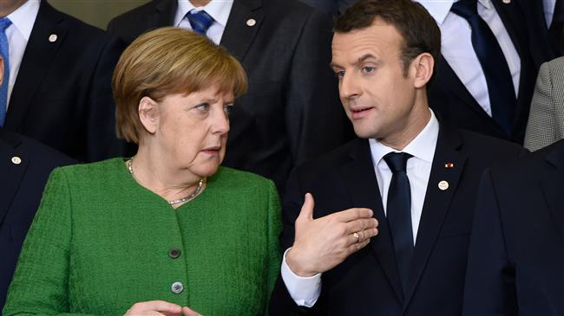
The West has been sharply divided in its reaction to Vladimir Putin’s decisive win in the Russian presidential election; while some European leaders have sent warm wishes to Putin in the hope of closer ties with Moscow, some others have taken advantage of the moment to say the strained relations would be irreversible under Putin.
Congratulations poured in from around the world after Putin garnered almost 77 percent of the vote, with an estimated turnout of 67 percent. But much of Europe was considering how to react to Putin’s election for a new six-year term.
The first European nation who broke the silence was Germany, whose Foreign Minister did not hesitate to call Russia a “difficult partner” under Putin.
German Chancellor Angela Merkel later congratulated Putin and expressed hope for further constructive cooperation.
“Today, it is vitally important to continue dialogue and maintain relations between our countries and nations. With this in mind, we should take efforts for constructive work on major bilateral and international problems to find proper solutions. I wish you success in your work to resolve the tasks facing you,” she told Putin in her message.
Meanwhile, French President Emmanuel Macron wished Putin “success for the political, democratic, economic and social modernization” of Russia.
Putin received the warmest message in the European Union from Italy’s right-wing parties. Matteo Salvini, leader of League party, quickly congratulated Putin in a tweet, saying, “Good job, president.”
Other European states, including Georgia and Poland, however, warned of what they called the “growing Russian threat.”
“There is a ‘now moment’ in the United States; there is a ‘now moment’ in London; there is a ‘now moment’ in Brussels … a moment of comprehension of the [threats] to security for all nations that are challenged by Russia,” said Georgian President Giorgi Margvelashvili.
Poland’s Foreign Ministry criticized Russia for holding the presidential elections in Crimea, calling it “illegal.”
Crimea declared independence from Ukraine and formally joined Russia after a referendum back in 2014. But the US and its Western allies see the move as Moscow’s “annexation” of the territory.
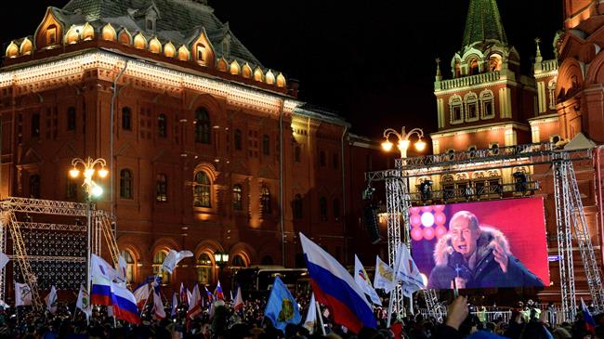
PressTV-Putin thanks voters after landslide election win
President Putin expresses gratitude to Russians after winning a landslide victory in the presidential election, in which he secured nearly 77 percent of the votes.
US President Donald Trump, however, has yet to congratulate his Russian counterpart on the reelection, according to the White House that said a phone call between the two leaders has yet to be set up.
Washington announced last week that it was enacting new sanctions on Russia, over accusations that Moscow had interfered in the US 2016 presidential election. Moscow has consistently denied the allegation.
Britain has also yet to react to Putin’s victory, since it has engaged in a row with Moscow after the recent nerve agent attack against former spy Sergei Skripal and his daughter Yulia in the English city of Salisbury.
The UK government blamed the attack on Russia, but Moscow denies the allegations over the use of the banned substance within the UK borders.
On the other side of the world, Japanese Prime Minister Shinzo Abe congratulated Putin in a phone call and the two leaders agreed to work together for denuclearization of the Korean Peninsula, according to the Japanese Foreign Ministry.
From the northeast corner of Africa, Egyptian President Abdel Fattah el-Sisi sent his “warmest congratulations” to Putin, according to a statement.
Saudi Arabia’s Crown Prince Mohammed bin Salman and his father King Salman also sent congratulations and wished the Russian president “constant good health and happiness and his people steady progress and prosperity.”
Israeli Prime Minister Benjamin Netanyahu also sent a congratulatory message to Putin and praised what he called “trust and understanding” between Tel Aviv and Moscow.
Iran, China, Syria, Kazakhstan, Belarus, Venezuela, Bolivia and Cuba were among the first countries to congratulate Putin.

